**Bahria University, Lahore Campus**

Department of Computer Sciences

Lab Journal 09

**(Fall 2023)**

|  |  |  |
| --- | --- | --- |
| Course: | **Digital Communication Network Lab** | Date: 30-11-2023 |
| Course Code: | CSL-320 | Max Marks: 20 |
| Faculty’s Name: | Dawood Akram | Lab Engineer: Muhammad Umar Nasir |

Name: _____________________________ Enroll No: _______________________

## Objective(s):

Students should understand to apply VLANS on packet tracer. To assign them to different ports. To assign them different names and validate them by showing they aren’t accessible from other VLANS.

## Tool(s) used:

CISCO Packet Tracer

**Task 1+ 2** Apply VLANS on packet tracer

Create a topology with one switch and multiple hosts like in the figure below.

[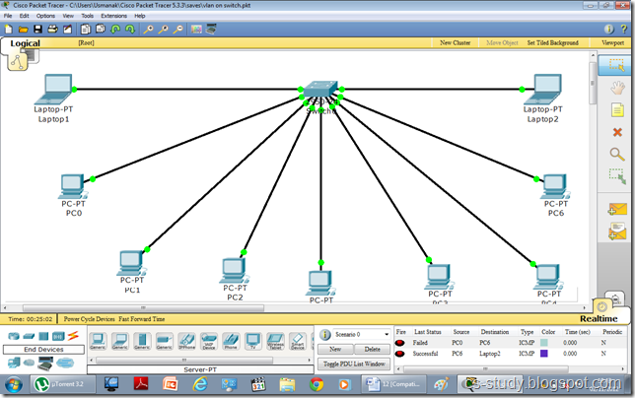](http://lh5.ggpht.com/-pNzEiHzPXGc/UJkQjyZcovI/AAAAAAAAA3E/qm4fZ4Tdg2I/s1600-h/1%25255B11%25255D.png)

If we go to the switch and enter the command “show vlan ”. It shows the following.    
 [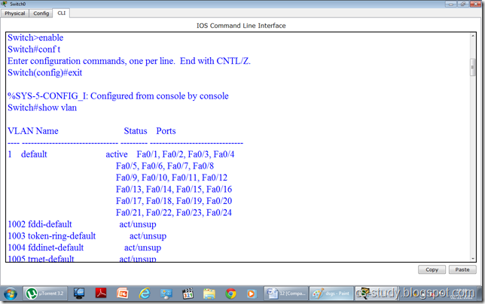](http://lh4.ggpht.com/-ydFpxBaR-88/UJkQpRApfUI/AAAAAAAAA3U/QU_SeDLOkys/s1600-h/afadsfadsf%25255B4%25255D.png)  
As we can see in the figure above all the interfaces are being displayed and they are all the part of the default vlan 1. Now let us apply vlans on the switch. We are going to create three vlans as follows.   
 [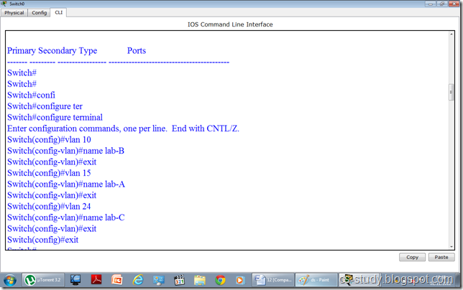](http://lh6.ggpht.com/-vq8qBywWN8M/UJkQtbjbr7I/AAAAAAAAA3k/WRhKSc5CrFs/s1600-h/dsgs%25255B4%25255D.png)  
Now, that we have created the vlans. Lets see if they are visible to us.   
[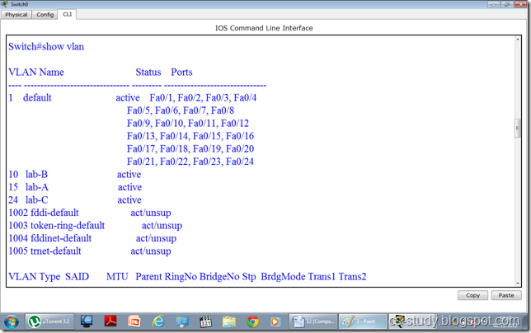](http://lh4.ggpht.com/-ZD-UwVmbqQo/UJkQxRBViFI/AAAAAAAAA30/veoo2Mgnimc/s1600-h/ds%25255B5%25255D.png)  
In the above figure, vlans are visible. Now, we are going to assign interfaces to vlans. They are two ways to do this.   
i. We can select an interface and assign that interface to a specific vlan  
ii. We can select multiple interfaces (range of interfaces) at once and assign those interfaces to vlan.   
In the figure below, we have done both of these.   
  
[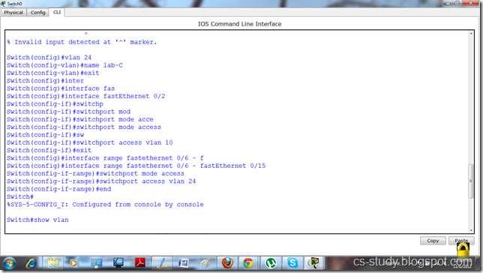](http://lh3.ggpht.com/-EvAMASAO9DM/UJkQ08h26SI/AAAAAAAAA4E/KC5eNy4O7QI/s1600-h/yyy%25255B4%25255D.png)  
Now, when we write “show vlan “ command and observe it. We will realize that interfaces have been assigned to desired vlans respectively.   
 [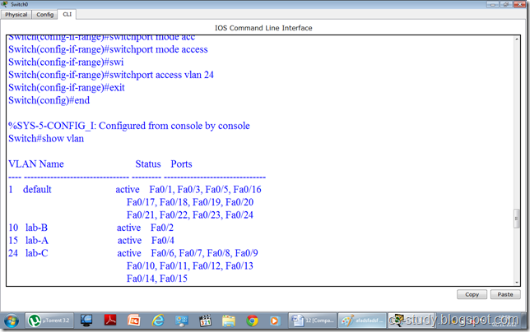](http://lh4.ggpht.com/-wbISqIF1trk/UJkQ5J2y5-I/AAAAAAAAA4U/TQP9NJQAHo0/s1600-h/ggggggggg%25255B4%25255D.png)  
Let us assign IP addresses to PCs. Open the PC.   
 [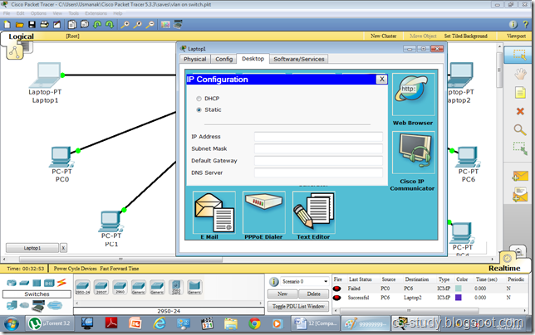](http://lh3.ggpht.com/-n91Qstex0qY/UJkQ84vev5I/AAAAAAAAA4k/RLotZCeuzhg/s1600-h/fff%25255B4%25255D.png)  
Assign IP address.   
 [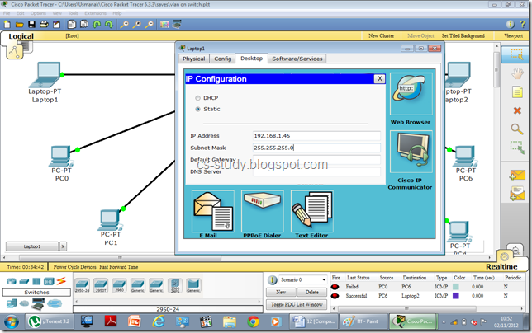](http://lh6.ggpht.com/-cCIPMuXPJZU/UJkRA2M5gdI/AAAAAAAAA40/At_0w1gLucI/s1600-h/kljljk%25255B5%25255D.png)  
After assigning IP addresses, when we try to communicate between two PCs belonging to two different vlans, it will fail. Thus, we have achieved our purpose.   
 [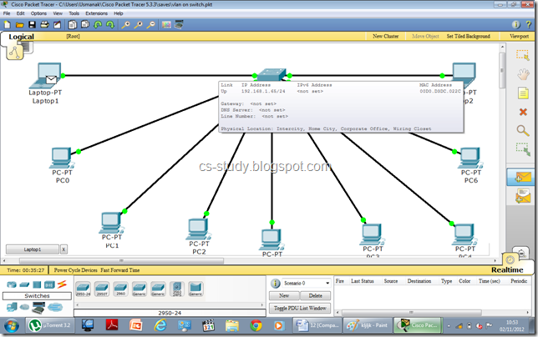](http://lh6.ggpht.com/-7fnhfFE8xgs/UJkRE7sl_TI/AAAAAAAAA5E/xsa_Btgaxt8/s1600-h/klj%25255B5%25255D.png)  
The message sending failure status can be seen in the bottom right corner.   
 [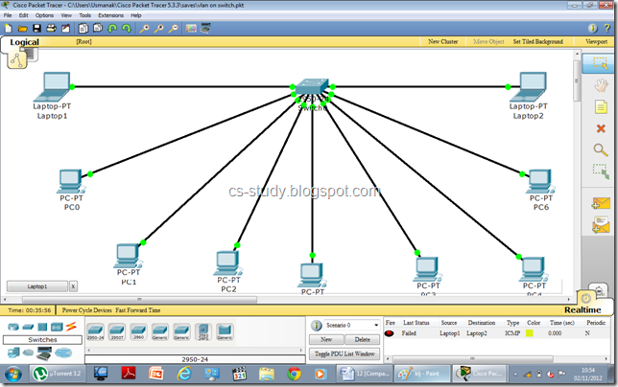](http://lh4.ggpht.com/-mGfIJzedNV8/UJkRIjb0LDI/AAAAAAAAA5U/gmu7rOB00RM/s1600-h/uu%25255B5%25255D.png)

**Task 3+4:**  VTP on packet tracer

VLAN Trunk Protocol (VTP) reduces administration in a switched network. When you configure a new VLAN on one VTP server, the VLAN is distributed through all switches in the domain. This reduces the need to configure the same VLAN everywhere. Let us apply VTP on packet tracer.

 [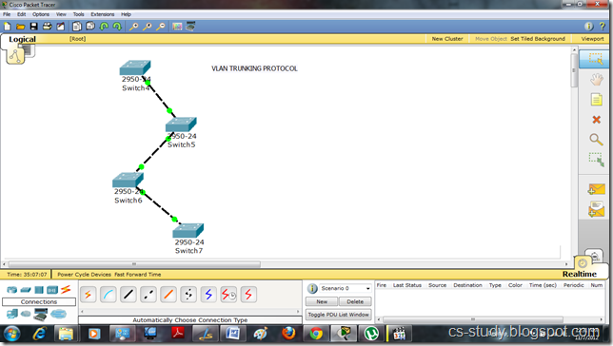](http://lh4.ggpht.com/-M3jHR8uqWqk/UJp0ue1s9DI/AAAAAAAAA9E/aJ8JILNtjd4/s1600-h/1%25255B7%25255D.png)  
Let us see vtp status by applying the command “show vtp status”.   
 [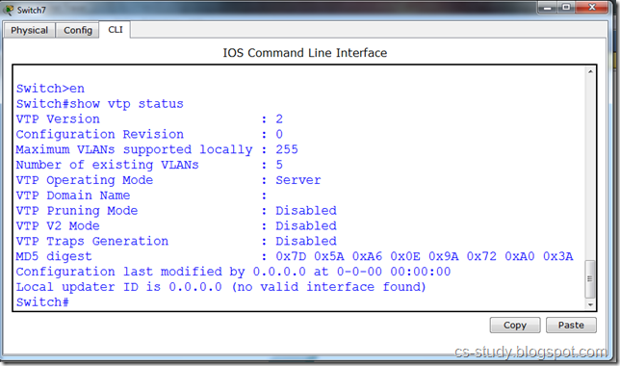](http://lh3.ggpht.com/-hwcoKl5w4yY/UJp0y8ph2nI/AAAAAAAAA9U/JJkE3CuFLT8/s1600-h/forall%25255B4%25255D.png)  
Let us set domain name. In VTP there should be only one domain name through out to synchronize between all the switches.   
 [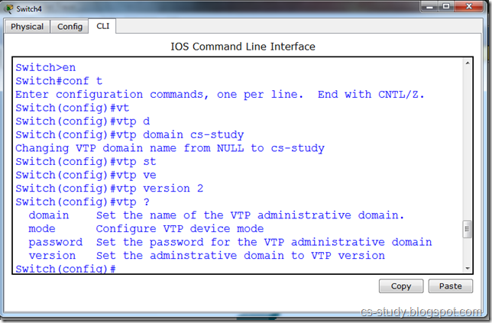](http://lh4.ggpht.com/-ZTHCBGQImtk/UJp03f5k2-I/AAAAAAAAA9k/tq3SqH6_FDc/s1600-h/2%25255B4%25255D.png)  
Domain name is set.   
[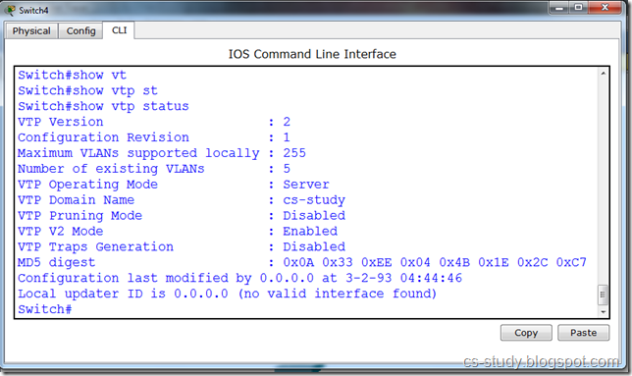](http://lh6.ggpht.com/-e0xZgzBxIpM/UJp08XQGyfI/AAAAAAAAA90/IebZECGlm7w/s1600-h/3%25255B4%25255D.png)  
In order for changes made in one switch to take place in other switches as well. we will have to trunk the interfaces. Only those interfaces that are connected.   
[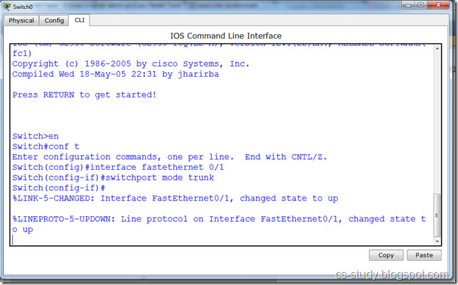](http://lh3.ggpht.com/-Y_9Dqh8aUTg/UJp1BqLWqII/AAAAAAAAA-E/qYGWcmYDdfk/s1600-h/88%25255B4%25255D.png)  
Or we can select a range of interfaces and trunk them.   
 [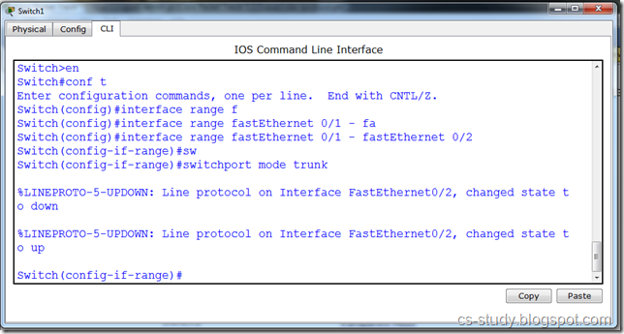](http://lh4.ggpht.com/-Tnf67HI0vfU/UJp1GuKf2KI/AAAAAAAAA-U/FepeVAOa1zE/s1600-h/99%25255B4%25255D.png)  
Now, when we check the status on other switches we can see that the domain name has been set on all the other switches as well.   
 [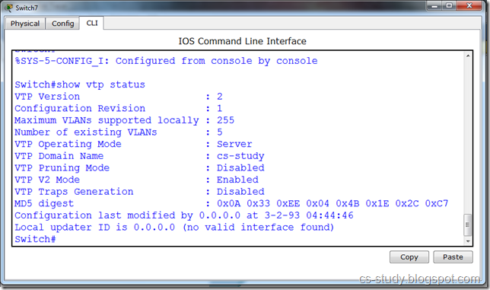](http://lh5.ggpht.com/-oMddX5mIdzE/UJp1MDXye5I/AAAAAAAAA-k/tzjjBO9x3E8/s1600-h/aftall%25255B4%25255D.png)  
Let us create VLAN.   
 [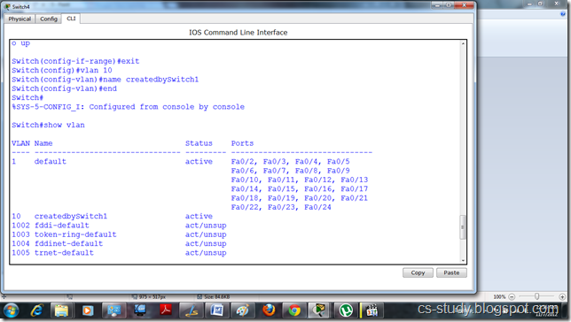](http://lh3.ggpht.com/-jB9IfppPdwE/UJp1Qclj8yI/AAAAAAAAA-0/vH0NwnHmEJM/s1600-h/4%25255B4%25255D.png)  
This vlan is shown in other switch due to the trunking .  
 [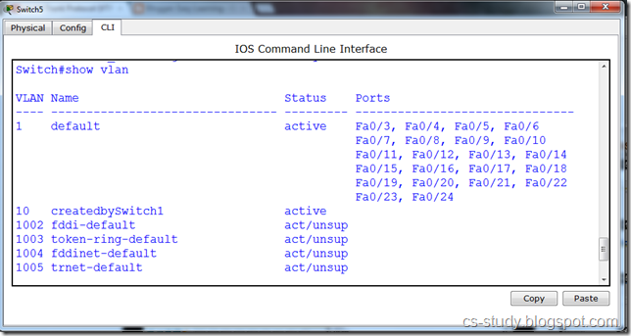](http://lh3.ggpht.com/-fcntu2tj-q0/UJp1UPN0yVI/AAAAAAAAA_E/6cMU-H35pRo/s1600-h/5%25255B4%25255D.png)  
Now, there are three modes in a vtp. 

i. Server   
ii. Client  
iii. Transparent

We are going to apply all three modes on different switches. We can create vlan in server mode, only use them in client mode. But the changes made in transparent mode are independent and does not have affect on other modes.   
[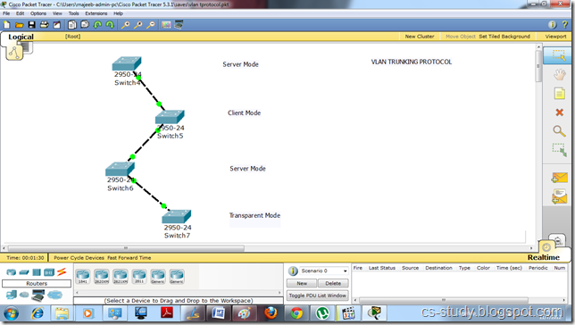](http://lh6.ggpht.com/-E4dAZh7zalo/UJp1ZZDqjLI/AAAAAAAAA_U/AiGo4lh11D4/s1600-h/jj%25255B4%25255D.png)  
  
Let us turn the switch 7 to transparent mode and create a vlan in it.   
 [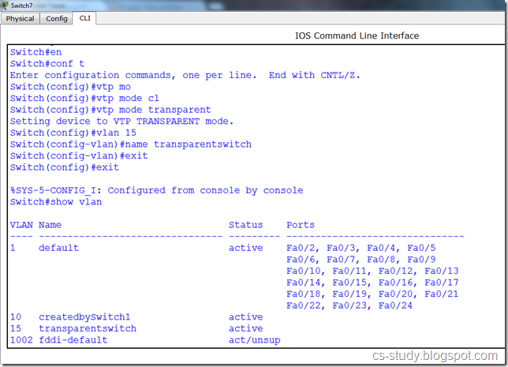](http://lh5.ggpht.com/-rw80OatLR18/UJp1eBq2-tI/AAAAAAAAA_k/nYACBU1WPTI/s1600-h/6%25255B4%25255D.png)  
The vlan created in transparent mode is not visible in the other modes.   
 [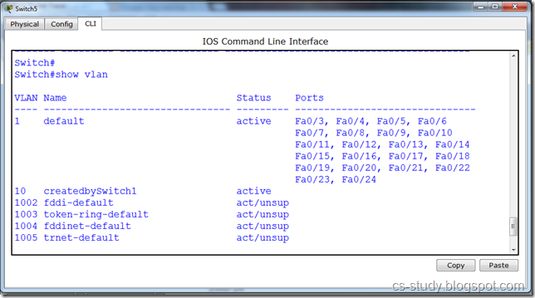](http://lh3.ggpht.com/-jxCgh-hsmlk/UJp1h8HtxmI/AAAAAAAAA_0/Lw0LYIDzHX4/s1600-h/7%25255B4%25255D.png)  
If we change the mode of vtp from server to client , we are unable to create vlan now in the client mode as shown in the message below.   
 [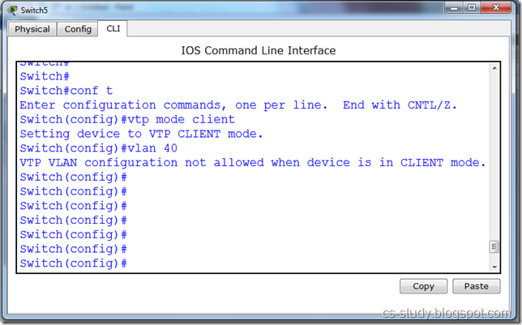](http://lh4.ggpht.com/-WthR9yCMPoI/UJp1lYJcv5I/AAAAAAAABAE/bUmqDQn8YuY/s1600-h/8%25255B4%25255D.png)

[](http://lh4.ggpht.com/-WthR9yCMPoI/UJp1lYJcv5I/AAAAAAAABAE/bUmqDQn8YuY/s1600-h/8%25255B4%25255D.png)